Center in Solid Geometry
# Source: AI Source: Provided by: [Data Path: Persons Table -> ID Column: 1, Name_En Column: Motasem Essam] -> From: [ChatGPT] on [7/25/2026]
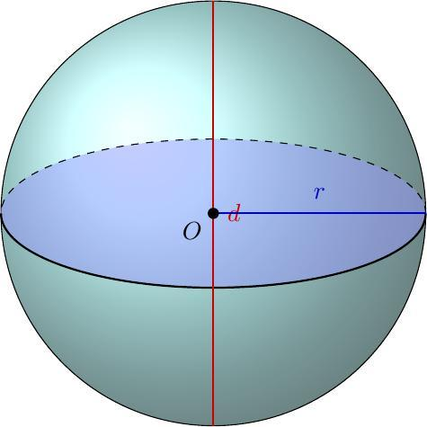
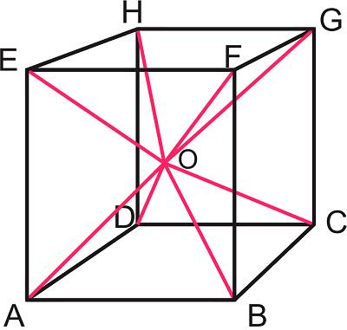
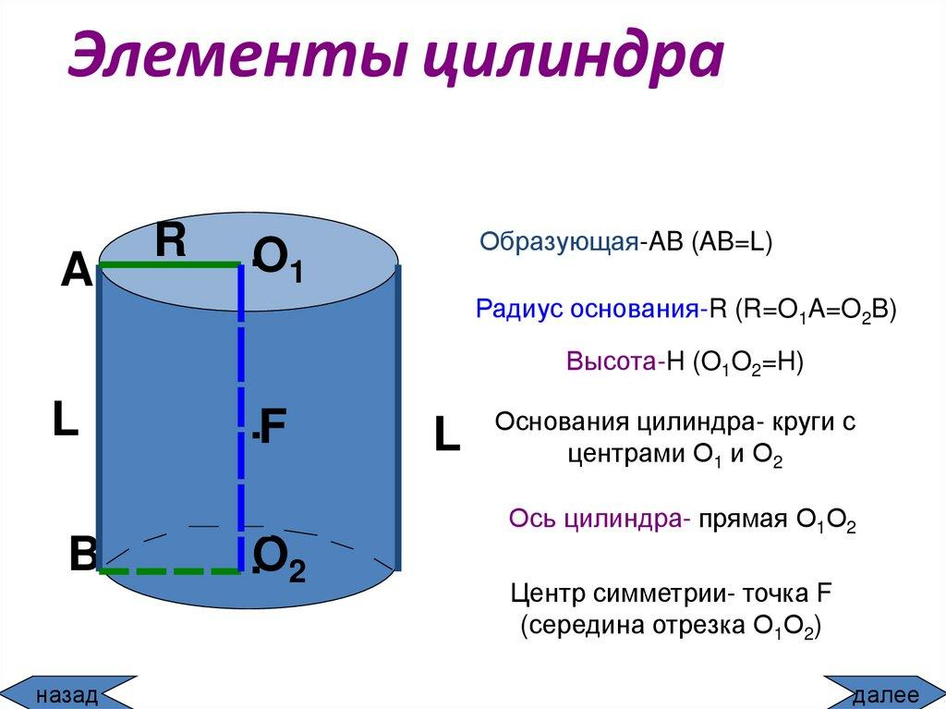

Definition
# Source: AI Source: Provided by: [Data Path: Persons Table -> ID Column: 1, Name_En Column: Motasem Essam] -> From: [ChatGPT] on [7/25/2026]
In solid geometry, a center is a point that serves as a reference for the position, symmetry, or geometric structure of a three-dimensional object.
Depending on the solid, its center may be the point equidistant from every point on a spherical surface, the intersection of its diagonals, or a point defined by its symmetry or mass distribution.
Not every solid has a unique geometric center. The exact meaning depends on the shape and the context.

Simple Definition
# Source: AI Source: Provided by: [Data Path: Persons Table -> ID Column: 1, Name_En Column: Motasem Essam] -> From: [ChatGPT] on [7/25/2026]
A center is a reference point associated with the middle or symmetry of a solid.
For example, the center of a sphere is equally distant from every point on its surface.

Types of Centers in Solid Geometry
# Source: AI Source: Provided by: [Data Path: Persons Table -> ID Column: 1, Name_En Column: Motasem Essam] -> From: [ChatGPT] on [7/25/2026]
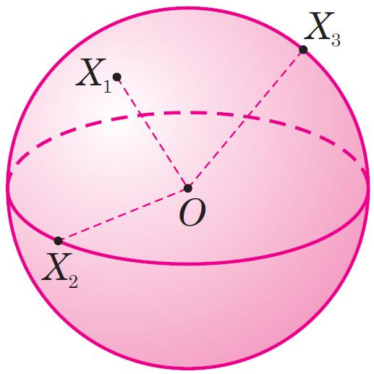

1. Center of a Sphere
# Source: AI Source: Provided by: [Data Path: Persons Table -> ID Column: 1, Name_En Column: Motasem Essam] -> From: [ChatGPT] on [7/25/2026]
The point inside a sphere that is equally distant from every point on its surface. It is the midpoint of every diameter.

2. Center of a Polyhedron
# Source: AI Source: Provided by: [Data Path: Persons Table -> ID Column: 1, Name_En Column: Motasem Essam] -> From: [ChatGPT] on [7/25/2026]
For regular or centrally symmetric polyhedra, the center is the central point associated with their symmetry. In a cube, it is the intersection of the body diagonals.
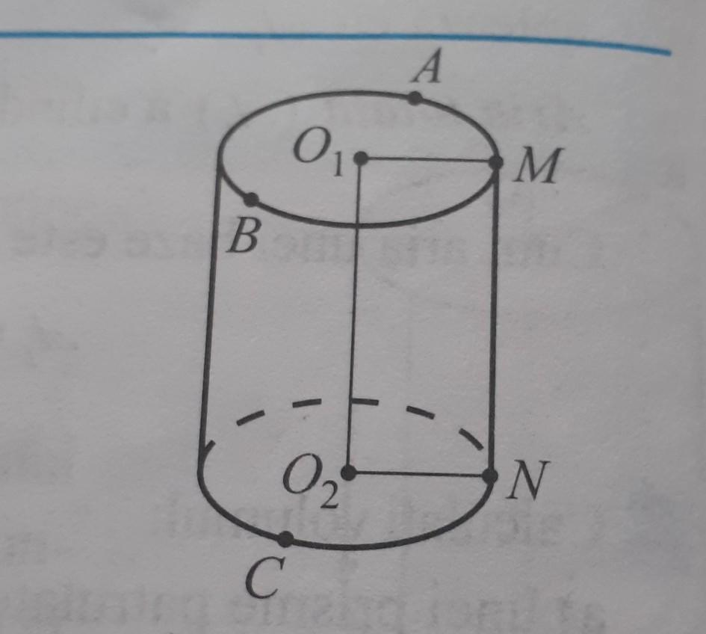

3. Center of a Circular Base
# Source: AI Source: Provided by: [Data Path: Persons Table -> ID Column: 1, Name_En Column: Motasem Essam] -> From: [ChatGPT] on [7/25/2026]
The center of a circular face or base. In a right circular cylinder, the two base centers lie on its central axis.
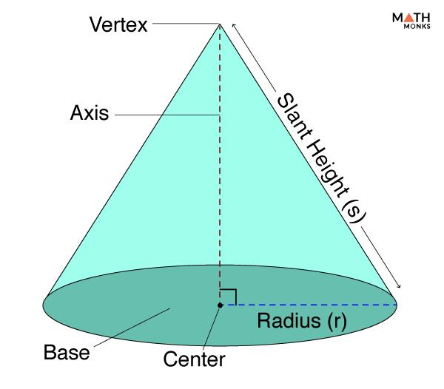

4. Center of a Solid's Base
# Source: AI Source: Provided by: [Data Path: Persons Table -> ID Column: 1, Name_En Column: Motasem Essam] -> From: [ChatGPT] on [7/25/2026]
The central point of a base, such as the center of a circle or the intersection of the diagonals of a rectangle. It is used to define the axis or height of many solids.
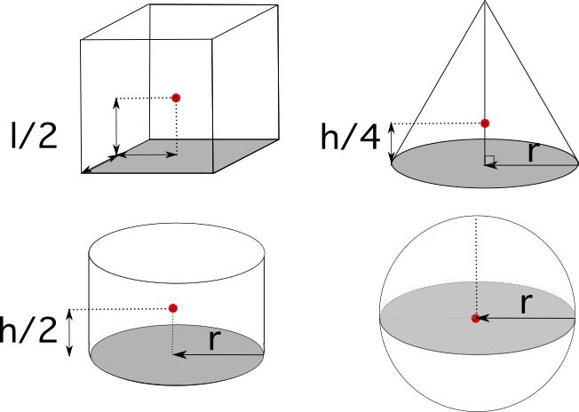

5. Center of Mass
# Source: AI Source: Provided by: [Data Path: Persons Table -> ID Column: 1, Name_En Column: Motasem Essam] -> From: [ChatGPT] on [7/25/2026]
The point representing the average position of a solid's mass. For a uniform solid with suitable symmetry, it often coincides with the geometric center.
Important distinction: These centers are not interchangeable. For an irregular solid, the center of mass may not coincide with a geometric center, and a unique geometric center may not exist.

Main Parts and Symbols
# Source: AI Source: Provided by: [Data Path: Persons Table -> ID Column: 1, Name_En Column: Motasem Essam] -> From: [ChatGPT] on [7/25/2026]
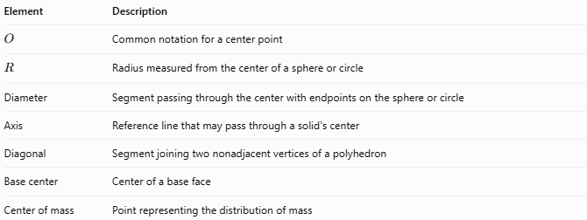
Element | Description
$$O$$ | Common notation for a center point
$$R$$ | Radius measured from the center of a sphere or circle
Diameter | Segment passing through the center with endpoints on the sphere or circle
Axis | Reference line that may pass through a solid's center
Diagonal | Segment joining two nonadjacent vertices of a polyhedron
Base center | Center of a base face
Center of mass | Point representing the distribution of mass

Mathematical Properties

A. Center of a Sphere
# Source: AI Source: Provided by: [Data Path: Persons Table -> ID Column: 1, Name_En Column: Motasem Essam] -> From: [ChatGPT] on [7/25/2026]
For a sphere with center $O$ and radius $R$, every point $P$ on its surface satisfies
$$\boxed{OP=R}$$
If the center is $O=\left(a,b,c\right)$, the equation of the sphere is
$$\boxed{{\left(x-a\right)}^{2}+{\left(y-b\right)}^{2}+{\left(z-c\right)}^{2}=R^{2}}$$

B. Center of a Cube
# Source: AI Source: Provided by: [Data Path: Persons Table -> ID Column: 1, Name_En Column: Motasem Essam] -> From: [ChatGPT] on [7/25/2026]
The center of a cube is the intersection of its four body diagonals.
For a cube with side length $s$, the length of a body diagonal is
$$\boxed{d=s\sqrt{3}}$$
The center divides every body diagonal into two equal segments:
$$\boxed{\text{Center-to-vertex distance}=\frac{s\sqrt{3}}{2}}$$

C. Center of a Circular Base
# Source: AI Source: Provided by: [Data Path: Persons Table -> ID Column: 1, Name_En Column: Motasem Essam] -> From: [ChatGPT] on [7/25/2026]
For a circle of radius $r$, all points on its circumference are at distance $r$ from its center $O$.
$$\boxed{OP=r}$$
For a cylinder, the centers of the two circular bases define its central axis.

D. Center of a Rectangular Solid
# Source: AI Source: Provided by: [Data Path: Persons Table -> ID Column: 1, Name_En Column: Motasem Essam] -> From: [ChatGPT] on [7/25/2026]
For a rectangular prism with length $l$, width $w$, and height $h$, its center is the intersection of its body diagonals.
If one corner is at $\left(0,0,0\right)$, the center is
$$\boxed{\left(\frac{l}{2},\frac{w}{2},\frac{h}{2}\right)}$$

Worked Examples
# Source: AI Source: Provided by: [Data Path: Persons Table -> ID Column: 1, Name_En Column: Motasem Essam] -> From: [ChatGPT] on [7/25/2026]
Example 1: Finding the Center of a Sphere
A sphere has radius $R=7\text{ cm}$. What is the distance from its center to any point on its surface?
By definition, this distance equals the radius.
$$OP=R$$
$$\boxed{OP=7\text{ cm}}$$
Example 2: Finding the Center of a Cube
A cube has side length $s=6\text{ cm}$. Find the distance from its center to one of its vertices.
First, calculate the body diagonal:
$$d=s\sqrt{3}=6\sqrt{3}\text{ cm}$$
The center is the midpoint of the body diagonal:
$$OC=\frac{d}{2}$$
$$\boxed{OC=3\sqrt{3}\text{ cm}≈5.20\text{ cm}}$$
Example 3: Finding the Center of a Rectangular Prism
A rectangular prism has length $8\text{ cm}$, width $6\text{ cm}$, and height $4\text{ cm}$. One corner is at the origin.
The center coordinates are
$$\left(\frac{8}{2,}\frac{6}{2,}\frac{4}{2})\right.$$
Therefore,
$$\boxed{O=\left(4,3,2\right)\text{ cm}}$$

Comparison with Related Geometric Concepts
# Source: AI Source: Provided by: [Data Path: Persons Table -> ID Column: 1, Name_En Column: Motasem Essam] -> From: [ChatGPT] on [7/25/2026]
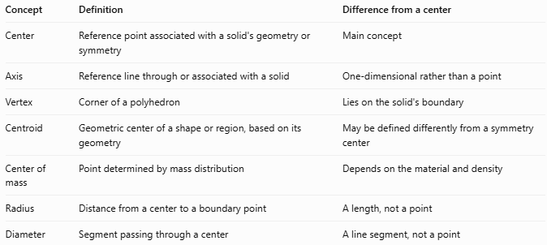
Concept | Definition | Difference from a center
Center | Reference point associated with a solid's geometry or symmetry | Main concept
Axis | Reference line through or associated with a solid | One-dimensional rather than a point
Vertex | Corner of a polyhedron | Lies on the solid's boundary
Centroid | Geometric center of a shape or region, based on its geometry | May be defined differently from a symmetry center
Center of mass | Point determined by mass distribution | Depends on the material and density
Radius | Distance from a center to a boundary point | A length, not a point
Diameter | Segment passing through a center | A line segment, not a point

Applications
# Source: AI Source: Provided by: [Data Path: Persons Table -> ID Column: 1, Name_En Column: Motasem Essam] -> From: [ChatGPT] on [7/25/2026]
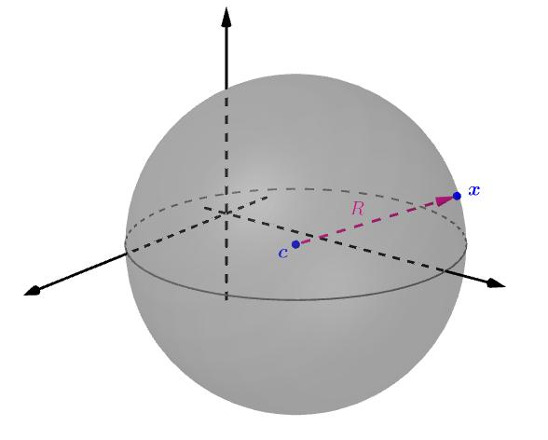
Engineering and CAD
Centers provide reference coordinates for modeling spheres, cylinders, circular holes, and symmetrical components.
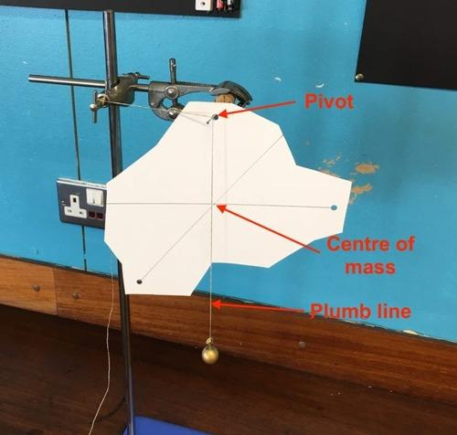
Physics
The center of mass helps analyze balance, stability, and motion.
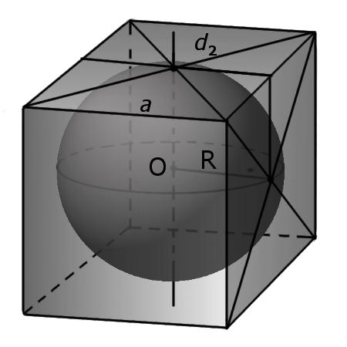
Mathematics
Centers help define radii, diameters, axes, diagonals, symmetry, and coordinate equations.

Key Points
# Source: AI Source: Provided by: [Data Path: Persons Table -> ID Column: 1, Name_En Column: Motasem Essam] -> From: [ChatGPT] on [7/25/2026]
- A center is a reference point associated with a solid's geometry, symmetry, or mass.
- The center of a sphere is equidistant from all points on its surface.
- The center of a cube is the intersection of its body diagonals.
- Circular bases have centers that can define the axis of a cylinder.
- The center of mass depends on how mass is distributed.
- Not every solid has one unique geometric center.
- The center, axis, radius, and diameter are related but different concepts.

Conclusion
# Source: AI Source: Provided by: [Data Path: Persons Table -> ID Column: 1, Name_En Column: Motasem Essam] -> From: [ChatGPT] on [7/25/2026]
A center in solid geometry is a reference point used to describe the position, symmetry, or structure of a three-dimensional object. Its exact definition depends on the solid: it may be the center of a sphere, the intersection of a polyhedron's body diagonals, the center of a circular base, or the center of mass. Understanding the distinction helps avoid confusing geometric points with lines, lengths, and physical properties.

